An Investigation into The Efficacy of High Frequency Trading Prediction.

## **Abstract:**

Previous studies to predict stock markets never took fundamental financial ratios into account, even if they did it was limited to 3-5 of them. The previous studies have large frequency typically of month or quarter making them ineffective for daily trading. This paper attempts to solve few of those problems and predict stock returns.

The model in this paper uses machine learning to predict the nonlinear behavioural pattern of National Stock Exchange of India. As mathematical models are limited the amount of equations one can derive with econometrics.

Total of 565 active companies listed in NSE were taken into modelling purpose for this study.

This model could easily be extended to high frequency trading by decreasing the frequency further down.

Table of Contents

**Abstract:** 1

1. THEORY AND HYPOTHESES 3

BACKGROUND STUDY 4

2. PROPOSED METHOD 9

2.1 Justification 10

2.2 Data selection 11

2.3 Data collection 14

2.4 Grouping stocks into sectors. 15

2.5 Panelising Datasets 17

2.6 Merging Dataset 18

2.7 Cleaning Data 18

2.8 Creating Model 18

2.9 Denormalization Values 18

2.10 Obtaining Actual Values and Error Values 18

3. RESULT 19

4. DISCUSSION 23

Conclusion: 24

Limitation and Recommendations for Future Research: 25

REFRENCES 26

APPENDIX 28

**Appendix A: Abbreviations** 28

**Appendix B: Links** 29

**Appendix C: Sectors Data** 30

**Appendix D: Filtered Financial Ratios** 32

An Investigation into The Efficacy of High Frequency Trading Prediction.

Many studies have already proved that stock market is inefficient. Thus, many others have attempted to predict the stock market. But none of the previous studies took all the financial fundamentals into account knowing so well that finical fundamentals are reason of stock price, mainly due the large frequency of release of finical statements by companies often as long as one quarter to one year. The previous studies used time-based prediction hoping to find the trend and seasonality of the stock prices.

This study attempts to solve all those problems, there by introducing the newer method of predicting the stock market returns with frequency as low as one day. By using the machine learning to predict the stock market we also include in out model any nonlinear behaviour of stock market.

But this study is devoid of any time-based parameters which might affect the outcome of modelling.

The NN model have been quite successful in predicting various non-linear patterns, thus we use NN model for predicting stock market.

We believe that there exists a relationship between financial fundamentals of the company and a no linear pattern of stock market, thus we try to find weather or no they exist by making a model and then trying to predict future stock.

Our model is an attempt to predict the returns and crises which could occur in stock market and thus signal the policy maker before the crises, as effect of very policy is lagged by some amount. Predicting this behaviour from before could possibly avert the situations.

# THEORY AND HYPOTHESES

High Frequency Trading is an automated trading platform built by powerful computers used by institution to transact in stock markets. The institution can be Investment Banker, Hedge Funds (Durbin, 2010).

Data analytics and Machine Learning have enabled the HFT to become automated.

Various institution is now using HFT to can gain favourable returns on investment.

The evolution of technology has now empowered even common man to analysis and predict various phenomenon. This project by taking advantage of technology attempts to predict the upward or downward movement of Indian Stock market.

But before we attempt to develop our model we wanted to analyse the previous work done by various scholars and researchers, so that we do not have to re-invent the wheel and at same time if possible improve on their work.

## BACKGROUND STUDY

The prediction of stock market can be classified into two types:

1. Fundamental Analysis: based on macroeconomic data and the basic financial status of companies like money supply, interest rates, divided yields, cash flow, book to market ratios and other financial ratios or lagged returns (Fama & French, 1988); (Ikenberry, Lakonishok, & Vermaelen, 1995).
2. Technical Analysis: based on assumption that that history will repeat itself in some defined pattern and there exist correlation between price and volume of stock traded for ex. Two such studies (Smirlock & Starks, 1985); (J., 1986) depicted the patterns and trends in price and volume charts.

Background Studies:

In 2012 a research paper (MacKenzie, Beunza, Millo, & Pardo-Guerra, 2012) contradicted that High Frequency Trading due to its complex nature was available to select few with high resource thus making market opaque to outsiders. It also argued that, as to how some hedge funds were able to avail public-limit order book from SEC thus causing the information imbalance as those people with access to public-limit order books were easily able to use it in their HFT platform howsoever the profits were small.

The public order books are beyond our reach and NSE provides them to only financial institute, hence we research will not include them. But, it also proves that HFT can help us make better investments.

A statistical analysis (Pant & Bishnoi, 2001) conducted on Indian Stock Market Indices to check for random walk hypothesis rejected the null hypothesis of random walk. Which meant that Indian Stock Market are not fully efficient that they do not follow any pattern, instead exited a clear pattern of stock prices changed in market.

This model conducted Q-statistics & Dickey-Fuller test on the datasets available from BSE. The study also concluded that there existed a clear pattern between daily and weekly return. It also encourages us to create a predictive model of the same.

In another study (Brogaard, Hendershott, & Riordan, 2014) which examined the role of HFTs in price discovery process it discussed about how the HFTs are replacing the intermediary in stock market i.e. replacing the brokers with automation.

The study took the transactional level data from NASDAQ to identify the buying and selling of large group of HFTs. This study also discussed as to how short lived are quality of HFT prediction generally 3-4 seconds. Also, some time the information if reached to consumer late can also lead to negative returns on investments.

Taking this study into accounts we have taken our data period to be of day rather than seconds. Also, infrastructure as of now does not allow for per second analysis.

In another financial research paper (Beaver, 1968) it was found that prices of stock can be used to determine the failure of the firm. This was done using a unique equation of finding the changes in stock prices and adding them with the divided on the security to deduce a factor which was then further used to predict firm’s failure.

The cross-sectional and time-series analysis of this research were consistent with proving that a. Investors recognize and adjust to price, b. change in prices causes the investor to use financial ratios for determine choice.

Hence this study enhances the theory of model that financial ratios can be good determinant

for predicting the stock prices.

In 2010 a research (Zhang, 2010) proved that there exists correlation between release of financial statement of the company and most often for short period of time, the market over-reacts while in long term the effect subsides.

Hence, we will take a variable time “t”, value of which will be reset quarterly, as most of the company release their financial information quarterly.

Statistical Methods:

In another study (Pai & Lin, 2005) a comparison among ARIMA and SVM was done, where the ARIMA method failed to identify the non-linearity of stock and thus SVM was suggested to be better model for predicting the stock market. So, the author used both ARIMA and SVM, taking advantage of ARIMA for predicting past and SVM for predicting future.

Since this study was done on S&P 500, hence we will try to implement SVM with other NN techniques on NSE.

In 2000 a model (Engle, 2000), developed using semi parametric approach by introducing a time variable, which resulted in a discovery of relation between short term and long-term price volatility. The modelling was done by passing intensities of ACD model to GARCH model. Where both returns, and risk were found to be negatively influenced by long durations.

Hence, we must also add a long-term time variable having longer reset time of around 1 year.

Neural Methods:

A Review research paper (Vui, Soon, On, & Alfred, 2013) mentioned how artificial neural network can be used to predict the market prices and average movement. The article disused how we can use the example of artificial neuron to develop mathematical model to develop ANN architecture. In this method the weights of variables were determined using many layers of inputs by calculated brute-forcing to determine the outputs.

In another comparative research (Vaisla & Bhatt, 2010) the authors predicted the stock market prices using first the statically model and then the NN method. They then calculated MAPE, MSE, RMSE of the errors generated in both the cases. The conclusion of the result was that NN model perform much better than their statistical counterpart.

Hence, we may better off by skipping statistical model and simply aim for NN method. But our model permits us use NN and statically operations on the same time, hence we choose statically model first.

Another literature review (R.K. & Pawar, 2010) suggested that the linear model of predicting stock was inferior with respect to Artificial neural network. The review suggested that NN was better at predicting the stock index, also it was able to describe better whether to buy or hold the stock.

Hence, if the time permits, we can grow the model to accommodate Machine Learning.

In another study (Boyacioglu & Avci, 2010) for predicting the returns on the stock prices of Istanbul Stock Exchange (ISE), ANIFS was used with six macroeconomic variables and three indices. The study concluded marking ANIFS an inexpensive or softer computing tool for enhancing the model.

Since, here the ANIFS were limited to only few financial fundamental data, our model will produce quite different result than this model if ANIFS were carried out.

A comparative study (Kara, Boyacioglu, & Baykan, 2011) done to predict the stock market of Istanbul between the technique ANN and SVM showed that ANN model was able to predict the prices with better accuracy than the SVM model. Here the ANN model had performance of 75.74% while the SVM has score of 71.52%.

Since score of ANN and SVM are close to each other our model will not biased among the choosing between ANN or SVM.

In conference proceeding (Kimoto, Asakawa, Yoda, & Takeoka, 1990) it was demonstrated that TOPIX stock market can be accurately predicted and simulated by using modular neural methods. In this method several modular neural methods were used to predict the market in tandem.

Thus, we will have to take great care to keep our system as modular as possible.

Another study (K & T, 1990)developed a pattern recognition technique to predict the prices of TOPIX where recurrent networks were used to decrease the mismatching patterns.

The study of which may be redundant in NN method.

Econometric Methods:

In another research paper (Maku & Atanda, 2012) it was found that in Nigeria Stock Exchange major determinants of the stock market were exchange rate, inflation, money supply, and economic growth rather than treasury bills in long run. This test was done using ADF and unit root test.

Since our project is to find short term movement of stock, we must remove any macroeconomic variables form our equation. But still they can be used as constants in equations.

In another study (Olweny & Kimani, 2011) by the use of Granger Causality test established the link between stock market performance and the economic growth of the country. This test was based on VAR model with ADF unit test to prove the same.

Since, this along with other papers point out that macroeconomic variables can influence the market and we now are convincing to add them in our model make it more accurate.

In another research paper (A.M. & Teneboah, 2008)quarterly data of macroeconomics like FDI, treasury bills, CPI, crude oil price, exchange rate were used to predict the stock market of Ghana. Where VECM method was used to predict the stock market. The research proved that there exists correlation between lagged values of interest rates and inflation.

Social Methods:

In a semantic analysis (Asur & Huberman, 2010) done using social media (twitter.com) to predict the sales office of movies provided another extension of predicting the stock market using social media. This paper proved that sentiments extracted from Twitter was outperforming market-based predictors. This model was made by finding out the rates at which tweets occurred using the API provided by Twitter.

Our study will no perform any semantic analysis, but we will keep in mind our model’s structure to accommodate them in future.

A psychological research (Alter & Oppenheimer, 2006) concluded that the fluency of name of stock, familiarity with name of company were positively correlated to performance of that stock. The research identified how cognitive approaches can outperform traditional numerical predictions.

Classifying all the names of companies listed in NSE is impossible without a survey with around 2000 questions (number of companies listed in NSE), hence we will not include them in our model.

In a social research (Rao, Davis, & Ward, 2000) the author studied why firms defected from NASDAQ to NYSE and how social identity can affect the probability of defection, and movement of price of stocks.

Hence to remove this bias we limit our research to NSE at same time remove all the firms inactive for 1 year.

# PROPOSED METHOD

The method of statics limits the model to only linear trends. Also, it is limited by the amount of formula one can learn on statistics. It is due to this reason that we changed our earlier method to the machine learning specifically Neural Networks.

Neural networks have capability of predicting even the non-linear relationship among the dependent and independent variables.

Also, various articles as discussed above have derived better results than conventional ARIMA models.

We start by creating a penal of following variables:

1. Daily return derived from stock closing price.
2. Filtered Financial Ratios as given in Appendix D.

**Re-Indexing:**

We re-index our panel as the NSE is closed on Saturday, Sunday and Holidays, thus now row exist for this date. We add null values for the entire columns.

**Interpolating:**

The empty rows created by above step is now filled using interpolating by the method of “spline” interpolation which is used in shipbuilding for creating elastic rulers.

**Normalizing the data:**

ML networks unlike there statically are affected by the magnitude of the independent variables. Thus, we normalized the data using flowing formula which scaled out data from 0 to 100, also our activator function will not work on negative value hence we normalize the data to positive scale:

$normalizedx=\frac{100∗X−min\left(x\right)}{max\left(x\right)−min\left(x\right)}$

**Shuffling Data:**

All the data are now shuffled so that our model will not biased on training and validation set.

**Splicing Dataset:**

We divide our dataset in 80:20 ratio where our model train on 80% of data (training set) and predicts on 20% of data (validation set) which gives us the RMSE values between training and Prediction set.

**Training model:**

Our model is trained using TensorFlow API developed by google for machine learning. We use DNN regressor with Adagard optimizer.

We also use RELU activation function in hidden layers of DNN regressor to introduce non-linearity in our model.

The matrix of independent variables is cross-multiplied by DNN regressor to construct a weight matrix on each node of the NN.

The model is iterated to target for obtaining lower loss function and by gradient descent.

**Testing model:**

During training we frequently post the RMSE value of prediction of training and validation set to determine if the model is learning or not.

Reusing Trained model:

Now we reuse the trained model to predict for stock prices from 2018-04-12 to 2018-04-18 and calculate the RMSE value of predicted and actual value.

## Justification

We know that various research (Vui, Soon, On, & Alfred, 2013); (Vaisla & Bhatt, 2010); (R.K. & Pawar, 2010); (Boyacioglu & Avci, 2010); (Kara, Boyacioglu, & Baykan, 2011) that NN methods are far better than statically methods like ETS, ARIMA, thus we went for neural network or NN method of machine learning rather than traditional econometrical methods to predict the stock prices.

But none of them consider the comprehensive list of financial ratios as taken up by us.

Our belief is that the large error in prediction was not the inherent incapability of the econometrics but the large amount of independent variable which had high correlation with the stock prices.

The problem lies not in the mathematics but the fundamental concept that mispricing of the stock can be easily calculated using financial ratio by using the concept of calculation of intrinsic value of firm.

It is the mispricing of stock which generates gains or loss for investors.

Most of the studies done before having hugely concentrated on econometrics but less on the financial report of the company even when knowing so well that there exists the concept of leveraged beta which is affected by Debt to Equity ratio of the company.

Our study in no means disregard the previous work but tries to append on them and make them more accurate by mixing the concept of finance and econometrics together.

Knowing so well that there are not one but many possible predictor variables for the stock intrinsic value, hence we take into our model as many financial ratios we can; the list of which can easily obtained from Appendix D.

## Data selection

We selected following dataset for our model:

Part A:

Time series data of every company traded in National Stock Exchange (NSE) for over 15 years. This data has a frequency of 1 day and contained following columns as shown in Figure 1:

1. Date of each day since 2008 (Will increase to 2003 if needed). Used as index.
2. Ticker column: Specifying the code of stock (For ex. Tata Steel it is TATASTEEL)
3. Open Price
4. High Price
5. Low Price
6. Last Price
7. Close Price
8. Total Quantity Traded: Number of stocks in circulation
9. Turnover: In lakhs of market capitalization.

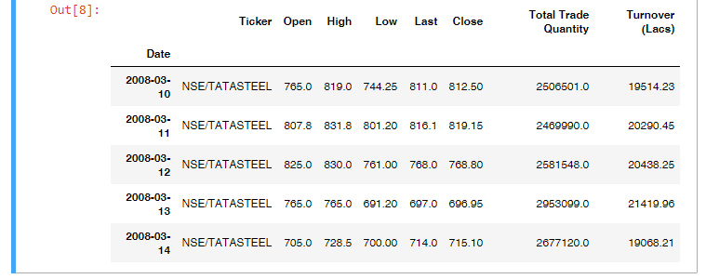

Figure1: Sourced from our model Jupyter notebook.

From the above listed columns, we only consider:

1. Stock returns calculated from closing price.
2. Total Quantity Traded.
3. Turnover: In lakhs of market capitalization.

Part B:

Various financial data of companies annual or quarterly (list of all the terms are also available in Appendix D) and listed below:

|  |  |  |  |
| --- | --- | --- | --- |
| **Sr. No** | **Indicator Code** | **Name** | **Period** |
| 1 | BSEVOL_Q | BSE Trade Volume | Quarterly |
| 2 | EQCAP_Q | Shareholders Equity | Quarterly |
| 3 | EBIDTSH_Q | EBIDTA Per Share (Unadjusted for splits/rights/bonus) | Quarterly |
| 4 | REVSH_Q | Revenue Per Share (Unadjusted for splits/rights/bonus) | Quarterly |
| 5 | ETR_Q | Corporate Tax Rate | Quarterly |
| 6 | MCAP_Q | Market Capitalization | Quarterly |
| 7 | OP1Q_Q | 1 Quarter Growth in Operating Profit | Quarterly |
| 8 | NI1Q_Q | 1 Quarter Growth in Net Income | Quarterly |
| 9 | OPMSH_Q | Operating Profit Per Share (Unadjusted for splits/rights/bonus) | Quarterly |
| 10 | EBIDT1Q_Q | 1 Quarter Growth in EBIDTA | Quarterly |
| 11 | PBT_Q | Profit Before Tax | Quarterly |
| 12 | PBDT_Q | Profit Before Depriciation and Tax | Quarterly |
| 13 | OPSH1Q_Q | 1 Quarter Growth in Operating Profit per Share | Quarterly |
| 14 | DIVSH_Q | Dividend Per Share (Unadjusted for splits/rights/bonus) | Quarterly |
| 15 | NP_Q | Net Income | Quarterly |
| 16 | DIV_PCT_Q | Percent of Dividend Declared (As a percent of Face Value) | Quarterly |
| 17 | EPS1Q_Q | 1 Quarter Growth in EPS | Quarterly |
| 18 | OI_Q | Other Income | Quarterly |
| 19 | INT_Q | Interest | Quarterly |
| 20 | SR_Q | Revenue | Quarterly |
| 21 | BSEH_Q | Unadjusted BSE High Price | Quarterly |
| 22 | OEXPNS_Q | Operating Expenses | Quarterly |
| 23 | SHARE_Q | Number of Outstanding Shares (Unadjusted for splits/rights/bonus) | Quarterly |
| 24 | BSEC_Q | Unadjusted BSE Close Price | Quarterly |
| 25 | TAX_Q | Income Tax Expense | Quarterly |
| 26 | BSEO_Q | Unadjusted BSE Open Price | Quarterly |
| 27 | FV_Q | Face Value | Quarterly |
| 28 | OP_Q | Operating Profit | Quarterly |
| 29 | DEP_Q | Depreciation Expense | Quarterly |
| 30 | EBIDTSH1Q_Q | 1 Quarter Growth in EBIDTA per Share | Quarterly |
| 31 | EBIDT_Q | Earning Before Interest, Depreciation & Taxes (EBIDTA) | Quarterly |
| 32 | EPS_Q | Earnings per Diluted Share (Unadjusted for splits/rights/bonus) | Quarterly |
| 33 | BSEL_Q | Unadjusted BSE Low Price | Quarterly |
| 34 | TI_Q | Total Income | Quarterly |

For example, Annual Cash Flow Return on Assets of Tata Consultancy is shown in Figure 2.

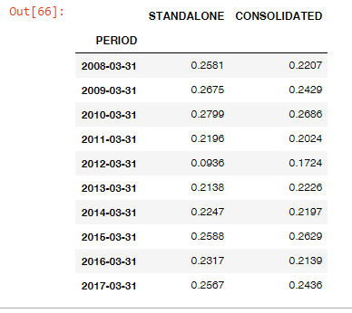

Figure 2: Sourced from our model Jupyter notebook.

## Data collection

The Part A of data came from NSE dataset which was available via Quandl website published by NSE and open sourced, Link(quandl.org) [4]. We selected 525 companies for our research.

The Part B of data was available as a sample from Quandl website published by: D’MARKET which have already purchased, (quandl.org) [2].

The use of python programming helped us aggregate data via API calls.

For example, here are API calls for:

Part A: 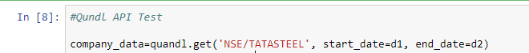

Figure 3: Sourced from our model Jupyter notebook.

Part B:



Figure 4: Sourced from our model Jupyter notebook.

While collecting data for PART A, we encountered following issues:

1. The time series dataset of all NSE Tickers for 10 years was so larger than 400Mb, which was saturating our Azure Instance ram.
2. Prices of most of the stocks were affected due to changes in sector of the industry, thus a newer problem of isolating the issue of sector have arrived.

To solve for above problems, we started grouping stocks based on sectors as described below in point 3.3.

## Grouping stocks into sectors.

A trader forum had an article listing all the NSE tickers and their respective sectors, we took those data and structured them.

From the data obtained we applied count function on “sector” column to obtain the number of industries in the sector we came across following data, snapshot of which is presented below in Figure 5 and the full list can be obtained in Appendix A.

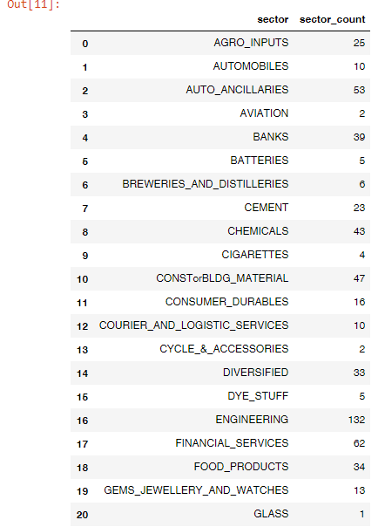

Figure 5: Sourced from our model Jupyter notebook.

Now from above data a program was made to loop through all the company’s data and save them in CSV file sector wise, available at [8]. The structure of which is showing in Figure 6.

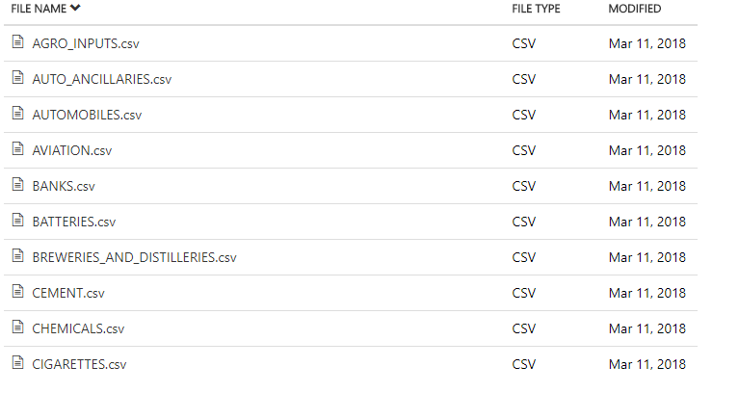

Figure 6: Sourced from our model Jupyter notebook.

The CSV file looks like following for AVIATION sector, where dash line represents all the between the above and below dates, Figure 7.

|  |  |  |  |  |
| --- | --- | --- | --- | --- |
| **Date** | **Ticker** | **Open** | **High** | **Low** |
| 10-03-2008 | NSE/JETAIRWAYS | 646.25 | 665 | 600 |
| 11-03-2008 | NSE/JETAIRWAYS | 630 | 648 | 605 |
| -------------------------------- | | | | |
| 08-03-2018 | NSE/JETAIRWAYS | 708.15 | 717 | 655.45 |
| 09-03-2018 | NSE/JETAIRWAYS | 698 | 709.75 | 682 |
| 06-10-2008 | NSE/KFA | 60.3 | 60.9 | 52.6 |
| 07-10-2008 | NSE/KFA | 53.5 | 56.5 | 50.9 |
| -------------------------------- | | | | |
| 22-09-2014 | NSE/KFA | 2.35 | 2.4 | 2.2 |
| 23-09-2014 | NSE/KFA | 2.25 | 2.25 | 1.95 |

Figure 7: Sourced from AVIATION.csv file of project

## Panelising Datasets

The data in the csv file is in the form of 2-dimensional array. This array although good for saving data to file is unusable for calculation as we have 3 axis instead of 2 axis, following are axis:

1. Date
2. Ticker
3. All the columns like Open, Close, Financial ratios

Now we have to convert this 2d data to 3d data where we can accommodate 3 axis.

Thus now our data looks like Figure 9:

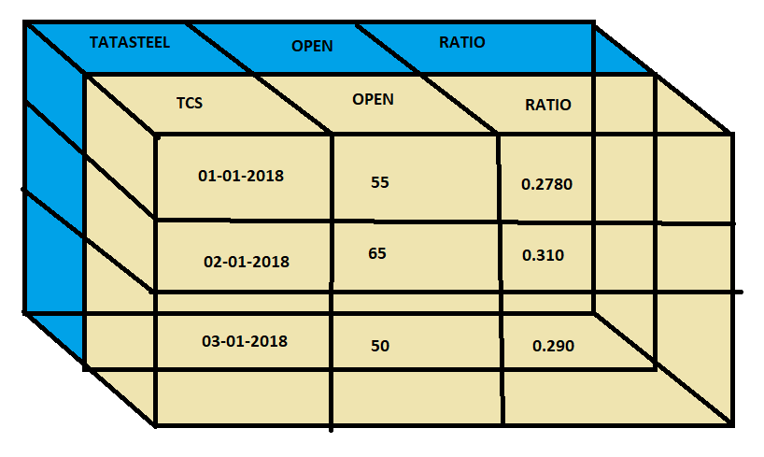

Figure 9: Made only for visualization via MS Paint.

Hence now we have slices of particular ticker and also of all of those tickers sharing same:

1. Date as Index
2. Various Columns like Open Price, Ratios etc.

Thus, our data is now panelised and ready for performing further calculation.

## Merging Dataset

The merging of dataset has been completed and now we faced following problems:

1. The frequency of ratios are quarterly while the stock prices are daily.
2. Only few ratios are available for all the companies.
3. The start and ending date of prices and ratios were not matching as they were unavailable for most of the companies (95%).
4. Many companies were not trading for year or quarter, thus bringing more empty spaces in our data.

## Cleaning Data

The above issues mentioned in merging dataset is nothing but the uncleaned data. So, we now address them in following way:

1. The ratios were merged using date as indexes. The empty spaces were interpolated.
2. We looped through all the companies listed in NSE with our core financial data and removed those ratios which were not available even for single companies, reducing our ratios from around 200 datasets to only 34. Kindly refer to Appendix D.
3. The merged panel was sliced with start date of ratios.
4. All those companies which are inactive for a month (30 days) were removed from our merged panel.

## Creating Model

We use following settings with DNN regressor:

1. Learning Rate: 0.0001
2. Batch Size: 5000
3. Hidden Layer Matrix: 24, 12, 6

After running DNN regressor as mentioned above in Proposed Method section we obtained the DNN regressor object which is used to predict returns from 2018-04-12 to 2018-04-18.

## Denormalization Values

The data obtained is now denormalized using following equation to obtain returns:

$X=min\left(x\right)+normalized{x∗\left(max\left(x\right)−min⁡\left(x\right)\right)}/{100}$

This was done to bring back the original data before the normalization. As all the values so obtained till now are in from 1 to 100 rather than the original values.

## Obtaining Actual Values and Error Values

Now the actual market returns of the companies in the sector are obtained and subtracted with the predicted values to get errors, RMSE, error percentage.

# RESULT

After performing all the above steps, we obtain following:

1. RMSE values of Testing and Validation Set:

Occasionally our model will pause in between training phase of training dataset and will predict some values for validation set. This gave us some error between training and validation set. This error was converted to RMSE value. This error was consistent for both training and test data set as can be seen from the graph.

The RMSE value was calculated using following formula:

$RMSE=√\left(\frac{∑{Ypredicted}^{2}−{Yactual}^{2}}{N}\right)$

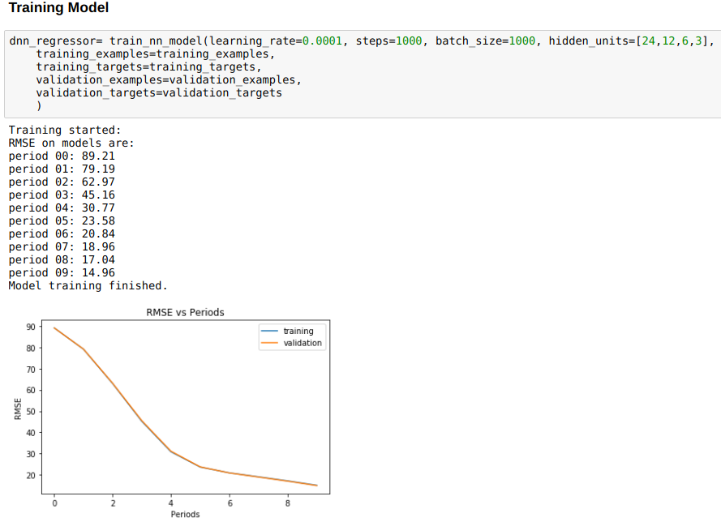

1. Predicted values (Full table Included in Excel File):

Now we obtained our trained object of NN regressor which was then used to predict the stock returns for all the companies from 12-04-2018 to 18-04-2018.

|  |  |  |  |  |
| --- | --- | --- | --- | --- |
| Date | NSE/ARIES | NSE/BAYERCROP | NSE/CHAMBLFERT | NSE/COROMANDEL |
| 12-04-2018 | -0.33431542 | -0.31243646 | 0.38680434 | 0.19269156 |
| 13-04-2018 | -0.33426464 | -0.31401527 | 0.4740417 | 0.18876958 |
| 14-04-2018 | -0.3342142 | -0.31559455 | 0.56084275 | 0.18484962 |
| 15-04-2018 | -0.33416367 | -0.31717324 | 0.6384337 | 0.1809293 |
| 16-04-2018 | -0.33411336 | -0.3187518 | 0.7167282 | 0.1770091 |
| 17-04-2018 | -0.33406293 | -0.32033074 | 0.79567194 | 0.17308855 |
| 18-04-2018 | -0.33401215 | -0.32190955 | 0.87461615 | 0.169168 |

1. Actual values (Full table Included in Excel File):

Now we obtained the actual share returns for the companies in the sector by calling the API.

|  |  |  |  |  |
| --- | --- | --- | --- | --- |
| Date | NSE/ARIES | NSE/BAYERCROP | NSE/CHAMBLFERT | NSE/COROMANDEL |
| 11-04-2018 |  |  |  |  |
| 12-04-2018 | -0.009623763 | -0.008471708 | -0.003599284 | -0.00929269 |
| 13-04-2018 | -0.011220664 | 0.005220083 | 0.113768578 | 0.009009497 |
| 14-04-2018 | 0.012130685 | 0.009551326 | -0.020169169 | 0.000977371 |
| 15-04-2018 | 0.008716759 | 0.009524511 | -0.012167909 | 0.002399946 |
| 16-04-2018 | 0.003673908 | 0.0096479 | -0.013200136 | 0.003022102 |
| 17-04-2018 | 0.03012639 | 0.000779727 | -0.000842342 | -0.005833115 |
| 18-04-2018 | -0.009542057 | -0.001716203 | 0.0025249 | -0.017898421 |

1. Error values (B-A) (Full table Included In Excel File):

Here we subtracted the values of table A(predicted) from table B (actual) to obtain the table of errors.

|  |  |  |  |  |
| --- | --- | --- | --- | --- |
| Date | NSE/ARIES | NSE/BAYERCROP | NSE/CHAMBLFERT | NSE/COROMANDEL |
| 12-04-2018 | 0.324691657 | 0.30396 | -0.390403624 | -0.20198425 |
| 13-04-2018 | 0.323043976 | 0.31924 | -0.360273122 | -0.179760083 |
| 14-04-2018 | 0.346344885 | 0.32515 | -0.581011919 | -0.183872249 |
| 15-04-2018 | 0.342880429 | 0.3267 | -0.650601609 | -0.178529354 |
| 16-04-2018 | 0.337787268 | 0.3284 | -0.729928336 | -0.173986998 |
| 17-04-2018 | 0.36418932 | 0.32111 | -0.796514282 | -0.178921665 |
| 18-04-2018 | 0.324470093 | 0.32019 | -0.87209125 | -0.187066421 |

1. RMSE values obtained from (Full table Included In Excel File):

Here we applied Root Mean Squared Error technique the most widely used metrics to compare predicted and actual values of models. Lower values signify robust model.

The formula so used to obtain them was:

$RMSE=√\left(\frac{∑{Ypredicted}^{2}−{Yactual}^{2}}{N}\right)$

|  |  |
| --- | --- |
| Date | RMSE |
| NSE/ARIES | 0.33791774 |
| NSE/BAYERCROP | 0.320766741 |
| NSE/CHAMBLFERT | 0.651464563 |
| NSE/COROMANDEL | 0.183642254 |
| NSE/DEEPAKFERT | 0.08554328 |
| NSE/EXCELCROP | 0.478950768 |
| NSE/FACT | 0.54490684 |
| NSE/GNFC | 0.481512281 |
| NSE/GSFC | 0.02761752 |
| NSE/INSECTICID | 0.408530608 |
| NSE/KSCL | 0.462006888 |
| NSE/MADRASFERT | 0.137763636 |
| NSE/MANGCHEFER | 0.170977139 |
| NSE/MONSANTO | 0.125832243 |
| NSE/NFL | 0.421738149 |
| NSE/RALLIS | 0.408905736 |
| NSE/RCF | 0.490385187 |
| NSE/SPIC | 0.237660254 |

1. Percentage Error:

Now we divide from our error table D, our actual table C, cell by cell and multiply all values by 100 to obtain percentage error. Here count is the number of days of prediction. Mean is the average percentage error. Std is standard deviation of error percentage. Min and max are the minimum and maximum values of percentage error.

|  |  |  |  |
| --- | --- | --- | --- |
|  | NSE/ARIES | NSE/BAYERCROP | NSE/CHAMBLFERT |
| count | 7 | 7 | 7 |
| mean | -101.037665 | -101.1024736 | -97.72740648 |
| std | 4.5220589 | 2.209428619 | 9.667388435 |
| min | -109.018178 | -103.0267752 | -103.5962254 |
| 25% | -103.119072 | -103.0146956 | -101.8738108 |
| 50% | -101.099599 | -101.6623659 | -100.930518 |
| 75% | -97.1322764 | -99.85514056 | -99.90858943 |
| max | -96.6431796 | -97.28850196 | -76.00030161 |

# DISCUSSION

At first glance looking into result we conclude following:

From figure A of result section. we conclude that our model was learning properly as the validation and test set have overlapping RMSE curve. Which was also accompanied by gradually decreasing value RMSE indicating that our model was learning the pattern well.

From, figure E when we compared our prediction to actual values the RMSE so obtained was so low that we thought that our model is very strong in prediction stock daily return.

**B**ut, when finding the error percentage or simply the relative comparison of error, we came to know that we have at least 100% error in our prediction and actual values.

## Conclusion:

Our attempt to predict stock prices started with taking the core fundamentals of companies into account. Due to very low frequency of release of fundamentals by companies we started interpolating the values of the fundamentals. To predict the non-linear behaviour, we started to use the Machine Learning or Neural Network techniques which required the data to be normalized to only positive values and that to with same scale as NN does not work on negative numbers and is affected by magnitude of the variables. The normalization was able to solve both this problem and thus have us a dataset to work on. When model was started training on test dataset and validating on validation set we got good result as both the training and validation set have same RMSE value indicating that our model was learning the patterns. Thus, we obtained our DNN regressor object as final output which was used to predict the outcome of stock. The DNN regressor was instructed to learn with 24, 12, 6, 3 nodes in series is same order to bring about the maximum possible non-linearity predicted.

Then we started to verify the model by collecting the actual dataset and finding the RMSE values with actual and predicted values and noticed the lower RMSE values thus proving the model was apt in predicting the stock returns.

It was not until that we started finding relative error percentage that our model started to give error percentage as large as 100%.

Hence our DNN model is not robust enough to to calculate the stock returns. It seems low RMSE values were due to low magnitude of daily log-based returns. This means that relative measure of comparing the error in the model are more significant then the RMSE values which are easily affected by the magnitude of error. It also shows that our model might be learning but the wrong patterns. The main reason of this could be attributed to the chaotic nature of high frequency trading which should have been accounted in the model.

We used the brute-forcing and gradient descent method of finding the stock returns, which could have been made stronger if the financial ratios so used could be made to calculate free cash flow of the company and then with the DNN regressor.

Thus, the stock market in short run or HFT are unpredictable or efficient. As for the long run are concerned this study could easily decrease the frequency to as low as quarter and thus predict the quarter-based result.

## Limitation and Recommendations for Future Research:

The log returns values are so low and despite normalization it was taking 4 places of decimals, thus might be causing floating point error during our model training.

The interpolation method we used can be changed to a better method, as it might have smoothed all the returns values too during the procedure (Procedure no. 2.7 Cleaning Data).

We should have never re-indexed our data set, knowing that it will creating more empty rows, but it was not clear whether Linear regression or DNN regression might work best for our data set initially.

We used modified RELU activator which could be replaced by Sigmoid activator enabling us to have negative values after normalization.

The model also does not include the one-hot encoded columns of dates of month, week, and the release schedule of financial statement, as they have magnitude of 1 while the rest of columns have weights from 1 to 100. We could not scale them and include in our model, as they might affect the result more than the normal ratios, one hot encoded columns have binary values of 100 or 0 (after normalization). To mitigate this problem, we could have made separate model of only dates columns and then used them and our original ratios-based model with different weight to accurately predict the stocks.

Hence, this research needs further fine tuning of procedure and addition of parameter which can encompass the chaotic nature into the model. More computational resources (able to perform long floating type operations) and time (training time for deeper neural nets of machine learning) if devoted can easily make this model more robust.

In the future result we might eliminate the mixing of data of companies in same sector as companies in similar sector might differ in the size drastically which again might have created anomalies while normalizing dataset.

# REFRENCES

A.M., A., & Teneboah, G. (2008). Do Macroeconomics Variables Play any Role in the Stock Market of Ghana. *MPRA Working Paper*, 1-22.

Alter, A. L., & Oppenheimer, D. M. (2006, June 13). Predicting short-term stock fluctuations. *Proceedings of the National Academy of Sciences of the United States of America, 13*, 9369-9372.

Asur, S., & Huberman, B. A. (2010, November 31). Predicting the Future With Social Media. *IEEE Xplore Digital Library*. doi:10.1109/WI-IAT.2010.63

Beaver, W. H. (1968). Market Prices, Financial Ratios, and the Prediction of Failure. *Journal of Accounting Research, 6*(2), 179-192. Retrieved 03 25, 2018, from http://www.jstor.org/stable/2490233

Boyacioglu, M. A., & Avci, D. (2010). An Adaptive Network-Based Fuzzy Inference System (ANFIS) for the prediction. *Expert Systems with Applications*, 7908-7912. doi:doi:10.1016/j.eswa.2010.04.045

Brogaard, J., Hendershott, T., & Riordan, R. (2014, August). High-Frequency Trading and Price Discovery. *The Review of Financial Studies, 27*(8), 2267-2306. Retrieved from http://www.jstor.org/stable/24465658

Durbin, M. (2010). *All About High-Frequency Trading.* Washington: McGraw-Hill Education.

Engle, R. F. (2000, Jan). The Econometrics of Ultra-High-Frequency Data. *Econometrica,*, 1-22. Retrieved from http://www.jstor.org/stable/2999473

Fama, E. F., & French, K. R. (1988). Dividend yields and expected stock returns. *Journal of Financial Economics, 22*(1), 3-25. doi:https://doi.org/10.1016/0304-405X(88)90020-7

Fama, E. F., & French, K. R. (1992, June). The Cross-Section of Expected Stock Returns. *The Journa Of Finance*, 427-465. doi:https://doi.org/10.1111/j.1540-6261.1992.tb04398.x

Ikenberry, D., Lakonishok, J., & Vermaelen, T. (1995). Market underreaction to open market share repurchases. *Journal Of Financial Economics, 39*(2-3), 181-208. doi:https://doi.org/10.1016/0304-405X(95)00826-Z

J., B. (1986). Eight Relative Strength Models. *Journal OF Portfolio Management*, 21-28.

K, K., & T, T. (1990). Stock price pattern recognition -a recurrent neural network approach. *Internatioal Joint Confrence on neural Networks*, (pp. 211-5).

Kara, Y., Boyacioglu, M. A., & Baykan, Ö. K. (2011). Predicting direction of stock price index movement using artificial neural. *Expert Systems with Applications*, 38.

Kimoto, T., Asakawa, K., Yoda, M., & Takeoka, M. (1990). Stock Market Prediction System with Modular Neural Networks. *International Joint Confrence On Neural Networks*, (pp. 1-6). San Diego, CA.

MacKenzie, D., Beunza, D., Millo, Y., & Pardo-Guerra, J. P. (2012). Drilling Through the Allegheny Mountains: Liquidity, Materiality and High-Frequency Trading. *London School of Economics and Political Science* , 1-29.

Maku, O. E., & Atanda, A. A. (2012, March). Determinants of stock market performance in Negeria: long term analysis. *Munich Personal RePEc Archive, 1*(3), 1-16. Retrieved from http://mpra.ub.uni-muenchen.de/35838/

Olweny, T. O., & Kimani, D. (2011). Stock market performance and economic growth Empirical Evidence from Kenya using Causality Test Approach. *Advances in Management & Applied Economics, 1*(3), 177-220.

Pai, P. F., & Lin, C. S. (2005). A hybrid ARIMA and support vector machines model in stock price forecasting. *The International Journal of Management Science, 33*, 497-505. doi:doi:10.1016/j.omega.2004.07.024

Pant, B., & Bishnoi, D. (2001). Testing Random Walk Hypothesis for Indian Stock Market Indices. *UTI Capital Market*.

R.K., D., & Pawar, D. (2010). Application of Artificial Neural Network for stock market predictions: A review of litrature. *International Journal of Machine Intelligence*, 14-17.

Rao, H., Davis, G. F., & Ward, A. (2000, June). Embeddedness, Social Identity and Mobility: Why Firms Leave the NASDAQ and Join theNew York Stock Exchange. *Administrative Science Quarterly, 45*(2), 268-292. Retrieved from http://www.jstor.org/stable/2667072

Reliance Industries Limited. (2016-2017, March). *Integrated Annual Report.* Mumbai: Reliance Industries Limited. Retrieved from https://ril.com: http://www.ril.com/getattachment/eb54f023-334f-4763-9f4a-dde72d315edb/AnnualReport_2016-17.aspx

Smirlock, M., & Starks, L. (1985). A Further Examination of Stock Price Changes And Transaction Volume. *Journal of Financial Research, 8*(3), 217-225. doi:https://doi.org/10.1111/j.1475-6803.1985.tb00404.x

Vaisla, K. S., & Bhatt, D. K. (2010). An Analysis of the Performance of Artificial Neural Network Technique for Stock Market Forecasting. *International Journal on Computer Science and Engineering*, 2104-2109.

Vui, C. S., Soon, G. K., On, C. K., & Alfred, R. (2013). A Review of Stock Market Prediction with Artificial. *Computing and Engineering*, 477-482. doi:DOI: 10.1109/ICCSCE.2013.6720012

Zhang, X. F. (2010). High-Frequency Trading, Stock Volatility, and Price Discovery. *Social Science Research Network*. Retrieved from https://www.ssrn.com/abstract=1691679

# APPENDIX

## **Appendix A: Abbreviations**

HFT High Frequency Trading

HFTs High Frequency Traders

NN Neural Network

ACD Autoregressive Conditional Duration

GARCH Generalized Autoregressive Conditional Heteroskedasticity

ANN Artificial Neural network

SVM Support Vector Machine

NSE National Stock Exchange

BSE Bombay Stock Exchange

NASDAQ National Association of Securities Dealers Automated Quotations

NYSE New York Stock Exchange

ANIFS Adaptive Neural Network Based Fuzzy Inference System

ARIMA Auto Regressive Integrated Moving Average

VAR Vector Auto Regressive

MAPE Mean Absolute Percent Error

MSE Mean Squared Error

RMSE Root Mean Square Error

SEC Securities and Exchange Commission

TOPIX Tokyo Stock Price Index

VECM Vector Error Correction Model

VAR Vector Auto Regression

ETS Error Trend Seasonality

DNN Dynamic RNN Estimator

RELU Rectified Linear Unit

## **Appendix B: Links**

1. [https://jguedu-my.sharepoint.com/personal/17jgbs-srathi_jgu_edu_in/_layouts/15/onedrive.aspx?id=%2Fpersonal%2F17jgbs-srathi_jgu_edu_in%2FDocuments%2FEmpirical%20Studies%20Data](https://jguedu-my.sharepoint.com/personal/17jgbs-srathi_jgu_edu_in/_layouts/15/onedrive.aspx?id=%2Fpersonal%2F17jgbs-srathi_jgu_edu_in%2FDocuments%2FEmpirical Studies Data)
2. <https://www.quandl.com/data/DEB-Core-India-Fundamentals-Data>
3. <http://www.traderji.com/community/threads/required-sector-wise-distribution-of-stocks-in-nse-and-bse.12224/>
4. https://www.quandl.com/data/NSE-National-Stock-Exchange-of-India

## **Appendix C: Sectors Data**

|  |  |  |
| --- | --- | --- |
|  | **Sector** | **sector_count** |
| 0 | AGRO_INPUTS | 25 |
| 1 | AUTOMOBILES | 10 |
| 2 | AUTO_ANCILLARIES | 53 |
| 3 | AVIATION | 2 |
| 4 | BANKS | 39 |
| 5 | BATTERIES | 5 |
| 6 | BREWERIES_AND_DISTILLERIES | 6 |
| 7 | CEMENT | 23 |
| 8 | CHEMICALS | 43 |
| 9 | CIGARETTES | 4 |
| 10 | CONSTorBLDG_MATERIAL | 47 |
| 11 | CONSUMER_DURABLES | 16 |
| 12 | COURIER_AND_LOGISTIC_SERVICES | 10 |
| 13 | CYCLE_&_ACCESSORIES | 2 |
| 14 | DIVERSIFIED | 33 |
| 15 | DYE_STUFF | 5 |
| 16 | ENGINEERING | 132 |
| 17 | FINANCIAL_SERVICES | 62 |
| 18 | FOOD_PRODUCTS | 34 |
| 19 | GEMS_JEWELLERY_AND_WATCHES | 13 |
| 20 | GLASS | 1 |
| 21 | HEALTHCAREorHOSPITALS | 6 |
| 22 | HOUSING_FINANCE | 6 |
| 23 | INFRASTRUCTURE_FACILITIES | 14 |
| 24 | IT | 102 |
| 25 | LEATHER_&_FOOTWEAR | 4 |
| 26 | MEDIA_AND_ENTERTAINMENT | 44 |
| 27 | MINING | 9 |
| 28 | NON_FERROUS_METALS | 12 |
| 29 | OIL_AND_GAS | 22 |
| 30 | OTHERS | 49 |
| 31 | PACKAGING | 20 |
| 32 | PAINTS | 4 |
| 33 | PAPER | 17 |
| 34 | PERSONAL_CARE | 11 |
| 35 | PETROCHEMICALS | 12 |
| 36 | PHARMACEUTICALS | 72 |
| 37 | PLANTATION | 10 |
| 38 | PLASTIC_PROCESSING | 15 |
| 39 | POWER | 37 |
| 40 | PRINTING_AND_STATIONERY | 5 |
| 41 | REAL_ESTATE | 29 |
| 42 | RETAIL | 8 |
| 43 | SHIPPING | 6 |
| 44 | STEEL | 50 |
| 45 | SUGAR | 21 |
| 46 | TELECOM | 18 |
| 47 | TEXTILE | 102 |
| 48 | TOURISM_or_HOTELS | 17 |
| 49 | TYRES | 7 |

## **Appendix D: Filtered Financial Ratios**

|  |  |  |  |
| --- | --- | --- | --- |
| **Sr. No** | **Indicator Code** | **Name** | **Period** |
| 1 | BSEVOL_Q | BSE Trade Volume | Quarterly |
| 2 | EQCAP_Q | Shareholders Equity | Quarterly |
| 3 | EBIDTSH_Q | EBIDTA Per Share (Unadjusted for splits/rights/bonus) | Quarterly |
| 4 | REVSH_Q | Revenue Per Share (Unadjusted for splits/rights/bonus) | Quarterly |
| 5 | ETR_Q | Corporate Tax Rate | Quarterly |
| 6 | MCAP_Q | Market Capitalization | Quarterly |
| 7 | OP1Q_Q | 1 Quarter Growth in Operating Profit | Quarterly |
| 8 | NI1Q_Q | 1 Quarter Growth in Net Income | Quarterly |
| 9 | OPMSH_Q | Operating Profit Per Share (Unadjusted for splits/rights/bonus) | Quarterly |
| 10 | EBIDT1Q_Q | 1 Quarter Growth in EBIDTA | Quarterly |
| 11 | PBT_Q | Profit Before Tax | Quarterly |
| 12 | PBDT_Q | Profit Before Depriciation and Tax | Quarterly |
| 13 | OPSH1Q_Q | 1 Quarter Growth in Operating Profit per Share | Quarterly |
| 14 | DIVSH_Q | Dividend Per Share (Unadjusted for splits/rights/bonus) | Quarterly |
| 15 | NP_Q | Net Income | Quarterly |
| 16 | DIV_PCT_Q | Percent of Dividend Declared (As a percent of Face Value) | Quarterly |
| 17 | EPS1Q_Q | 1 Quarter Growth in EPS | Quarterly |
| 18 | OI_Q | Other Income | Quarterly |
| 19 | INT_Q | Interest | Quarterly |
| 20 | SR_Q | Revenue | Quarterly |
| 21 | BSEH_Q | Unadjusted BSE High Price | Quarterly |
| 22 | OEXPNS_Q | Operating Expenses | Quarterly |
| 23 | SHARE_Q | Number of Outstanding Shares (Unadjusted for splits/rights/bonus) | Quarterly |
| 24 | BSEC_Q | Unadjusted BSE Close Price | Quarterly |
| 25 | TAX_Q | Income Tax Expense | Quarterly |
| 26 | BSEO_Q | Unadjusted BSE Open Price | Quarterly |
| 27 | FV_Q | Face Value | Quarterly |
| 28 | OP_Q | Operating Profit | Quarterly |
| 29 | DEP_Q | Depreciation Expense | Quarterly |
| 30 | EBIDTSH1Q_Q | 1 Quarter Growth in EBIDTA per Share | Quarterly |
| 31 | EBIDT_Q | Earning Before Interest, Depreciation & Taxes (EBIDTA) | Quarterly |
| 32 | EPS_Q | Earnings per Diluted Share (Unadjusted for splits/rights/bonus) | Quarterly |
| 33 | BSEL_Q | Unadjusted BSE Low Price | Quarterly |
| 34 | TI_Q | Total Income | Quarterly |